МІНІСТЕРСТВО ОСВІТИ І НАУКИ УКРАЇНИ
Національний аерокосмічний університет ім. М.Є. Жуковського
“Харківський авіаційний інститут”

Кафедра комп’ютерних систем, мереж і кібербезпеки (503)

Лабораторна робота № 2

з дисципліни “WEB-програмування”

Повторение базовых принципов построения гипертекстовых страниц
ХАІ.503.535Б.19О. 050102, 1705047

Виконав студент гр. 535Б Климов
(№ групи) (П.І.Б.)
В.С.

(підпис, дата)
Перевірив доцент каф. 503
(науковий ступінь, вчене звання, посада)
Морозова О.І.
(підпис, дата) (П.І.Б.)

2019
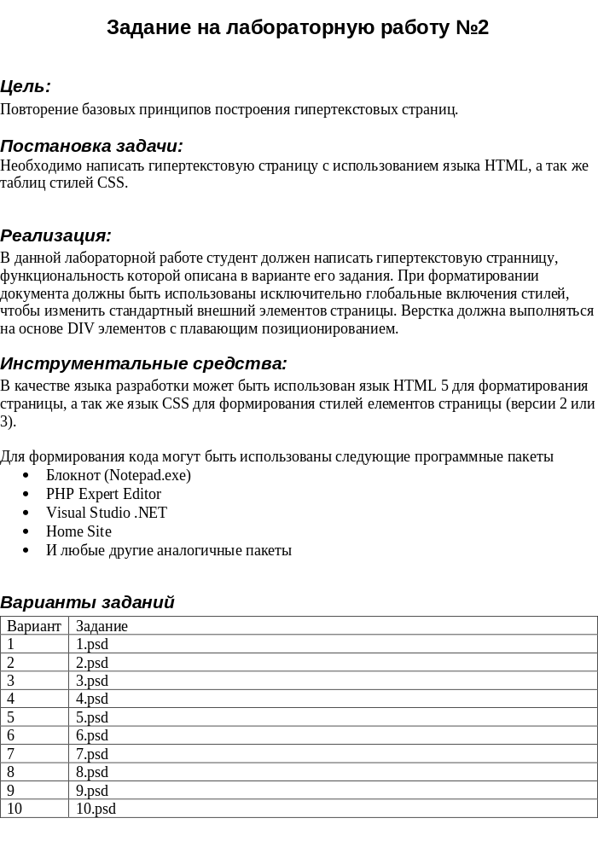
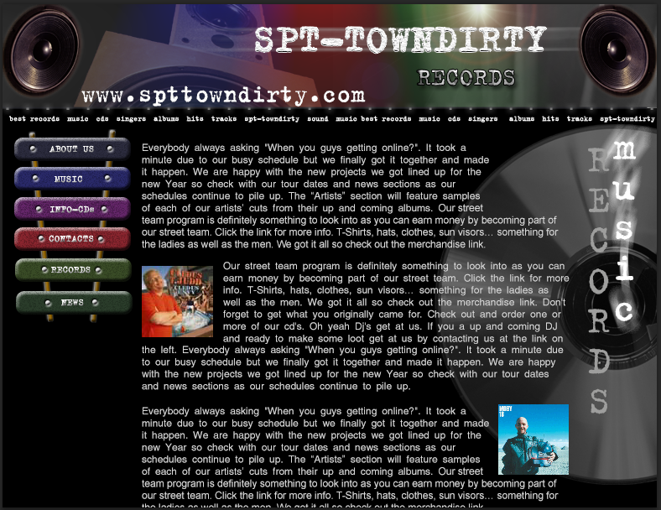

Рис. 1 - картинка гипертекстовой страницы, которая соответствует этому варианту 7

Часть 2. HTML и CSS файлы для решения задачи

Файл - index.html

<!DOCTYPE html>
<html>
<head>
<meta charset="utf-8" />
<title>Климов В.С.</title>
<link rel="stylesheet" href="styles/style.css" />
</head>
<body>
<div id="canvas">
<header>
<div id="headRef"><a href="index.html">www.spttowndirty.com</a></div>
</header>
<main>
<div id="menu" class="hText">
<ul>
<li>best records</li>
<li>music</li>
<li>cds</li>
<li>singers</li>
<li>albums</li>
<li>hits</li>
<li>tracks</li>
<li>spt-towndirty</li>
<li>sound</li>
</ul>
</div>
<div class="wrap-content">
<div class="col1">
<ul id="list">
<li><a href="index.html">about us</a></li>
<li><a href="redirect.html">music</a></li>
<li><a href="form.html">info-cds</a></li>
<li><a href="">contacts</a></li>
<li><a href="">records</a></li>
<li><a href="">news</a></li>
</ul>
</div>
<div class="col2">
<div>
<div class="text textColor">
<img class="content-img-r" src="images/img1.jpg" alt="img1">
Everybody always asking "When you guys getting online?". It took a
minute due to our busy schedule but we finally got it together and made
it happen. We are happy with the new projects we got lined up for the
new Year so check with our tour dates and news sections as our
schedules continue to pile up. The “Artists” section will feature samples
of each of our artists’ cuts from their up and coming albums. Our street
team program is definitely something to look into as you can earn money by becoming part of
our street team. Click the link for more info. T-Shirts, hats, clothes, sun visors… something for
the ladies as well as the men. We got it all so check out the merchandise link.
</div>
<div class="text textColor">
<img class="content-img-l" src="images/img2.jpg" alt="img2">
Our street team program is definitely something to look into as you can
earn money by becoming part of our street team. Click the link for more
info. T-Shirts, hats, clothes, sun visors… something for the ladies as
well as the men. We got it all so check out the merchandise link. Don't
forget to get what you originally came for. Check out and order one or
more of our cd's. Oh yeah Dj's get at us. If you a up and coming DJ
and ready to make some loot get at us by contacting us at the link on
the left. Everybody always asking "When you guys getting online?". It took a minute due
to our busy schedule but we finally got it together and made it happen. We are happy
with the new projects we got lined up for the new Year so check with our tour dates
and news sections as our schedules continue to pile up.
</div>
<div class="text textColor">
<img class="content-img-r" src="images/img3.jpg" alt="img3">
Everybody always asking "When you guys getting online?". It took a
minute due to our busy schedule but we finally got it together and made
it happen. We are happy with the new projects we got lined up for the
new Year so check with our tour dates and news sections as our
schedules continue to pile up. The “Artists” section will feature samples
of each of our artists’ cuts from their up and coming albums. Our street
team program is definitely something to look into as you can earn money by becoming part of
our street team. Click the link for more info. T-Shirts, hats, clothes, sun visors… something for
the ladies as well as the men. We got it all so check out the merchandise link.
</div>
</div>
</div>
</div>
</main>
</div>
</body>
</html>

Файл – Laba_1.css

@font-face {
font-family: B52; /* ��� ������ */
src: url(../fonts/B52.woff); /* ���� � ����� �� ������� */
}
body {
margin: 0;
background-color: black;
font: normal 12px Arial;
color: white;
}
#canvas {
width: 780px;
margin: 0 auto;
}
header {
background-image: url(../images/Header.jpg);
height: 128px;
}
#headRef {
padding-left: 90px;
padding-top: 90px;
font: normal 30px B52;
}
header img {
vertical-align: bottom;
}
#underheaderline{
margin-left: 5px;
margin-bottom: 10px;
}
main {
/*height: 470px;*/
background-image: url(../images/Disk.jpg);
/*background-position: right;*/
background-position-x: right;
background-position-y: 20px;
background-repeat: no-repeat;
}
/*main:after {
content: "";
clear: both;
float: none;
display: block;
}*/
#menu ul {
margin: -5px 0 5px;
padding: 0;
text-align: center;
text-transform: uppercase;
}
.clearfix {
clear: both;
float: none;
}
#menu ul li {
display: inline-block;
padding: 5px;
text-decoration: none;
text-align: center;
list-style: none;
color: white;
}
#menu li:hover {
background-color: #990033;
color: Tomato
}
.textColor {
color: white;
}
.hText {
font: 7pt B52;
font-weight: bold;
}
#disk{
float:right;
}
.text {
font: normal 12px Arial;
line-height: 1.5;
margin-bottom: 20px;
}
.col1 {
float: left;
width: 20%;
background-image: url(../images/stics.png);
background-position: top left;
background-repeat: no-repeat;
margin: 0 1.5%;
background-size: 100% 100%;
}
#list {
list-style-type: none;
margin: 0;
padding: 7px 0px 3px 0px;
text-transform: uppercase;
}
#list a {
padding: 6px 0 7px;
margin-bottom: 8px;
}
a {
color:white;
display: block;
text-decoration: unset;
}
#list li {
/*padding: 6px 0 14px;*/
text-align: center;
}
.col2 {
float: left;
width: 65%;
}
.content-img-r {
float: right;
padding: 0 0 0 8px;
}
.content-img-l {
float: left;
padding: 0 8px 0 0;
}
.wrap-content {
position: relative;
font: 10pt B52;
}
.wrap-content:after {
display: block;
clear: both;
float: none;
content: "";
}
#submitButton {
width: 80px;
height: 30px;
}
.formElem {
/*height: 5%;
width:33%;
float: left;
margin: 10px;*/
font: normal 10px Arial;
}
.err:after{
clear: both;
float: none;
}
span:after {
clear: both;
float: none;
}
.err {
width: 50%;
/*float: left;
margin: 10px;*/
color: red;
font: normal 12px Arial;
}
#redirSpan {
margin: 200px 100px 200px 200px;
font-size: 16px;
}
input {
background-color: gray;
border: 2px solid #404040;
height: 25px;
width: 160px;
color: white;
border-radius: 5px;
}
textarea {
background-color: gray;
border: 2px #404040 solid;
color: white;
width: 160px;
height: 130px;
border-radius: 5px;
}
::-webkit-input-placeholder { /* Chrome/Opera/Safari */
color: #ff6a00;
}
select {
background-color: gray;
height: 31px;
width: 100px;
border: 2px solid #404040;
color: white;
border-radius: 5px;
}
.clear {
content: "";
display: block;
float:none;
clear:both;
}
td {
padding-top:10px;
}
#about {
vertical-align:top;
}
table {
margin-bottom: 60px;
width: 100%;
}

Часть 3. Картинка полученного результата
Полученная гипертекстовая страница с использованием языка HTML, а также таблиц стилей CSS продемонстрированная на рис. 2

Рис. 2

Выводы
В результате выполнения лабораторной работы была разработана гипертекстовая страница с использованием языка HTML, а также таблиц стилей CSS. Научился использовать глобальные и локальные включения, работать с основными тегами и свойствами.

